Volume - is a single accessible storage area with a single file system.

Disk Partition - is a logical division of a hard disk

**Volume Types**

* **Simple Volume**: it is a physical disk that functions like a physically independent unit.
* **Mirrored Volume**: it uses two copies on separate physical disks to duplicate data. When new data is written to the mirrored volume, it will be written to the two copies. If one of the physical disks fails, the data on the disk becomes unavailable, but mirrored volume is a fault-tolerant volume, which means the data on the other physical disk is still usable.
* **Striped Volume**: it is created by combing areas of free space on two or more disks into one logical volume. This volume type does not provide fault tolerance, which means the entire volume will fail when one of the disks containing a striped volume fails.
* **Spanned Volume**: it combines areas of unallocated space from multiple disks into one logical volume. When new data is written into a spanned volume, data will first fill up the free space on the first disk, the fill up that on the next disk, and so on.
* **RAID-5 Volume**: it is a volume with data and parity striped intermittently across three or more physical disks. As a fault-tolerant volume, it allows you to recreate the data that was on the failed portion from the remaining data and parity when a portion of a physical disk doesn’t work.

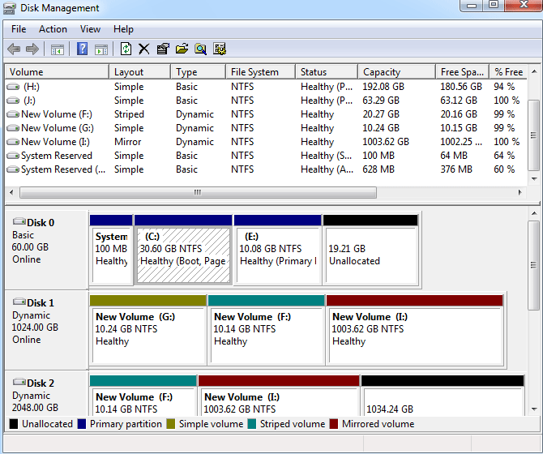

**Partition Types**

* **Primary Partition**: it is a hard disk partition that is identified by a drive letter and is used for storing Windows operating systems and other data. The C drive is often a primary partition.
* **Logical Partition**: it is a contiguous area on the hard disk and it consists of one or more logical partitions.
* **Extended Partition**: it is a partition that consists of additional logical partitions. Differing from a primary partition, you don’t need to assign a drive letter to it.

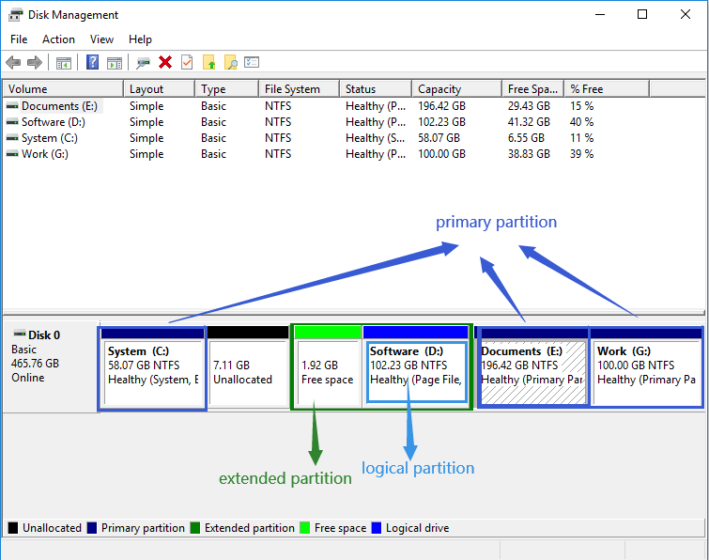

**Max Size**

What is the max size of a partition and a volume?

As we know, contiguous space on the same disk can be divided into one area, and therefore the max size of a partition is the hard drive space.

In contrast, the max size of a volume can be larger – when it is not a simple volume. The other four types of volume can be created on two or more disks and this combines these disks into a large volume, so that’s why the max size of a volume is larger than that of a partition.

**Creation**

The biggest difference between a volume and partition is the type of disk used. **A volume is created on a dynamic disk, while a partition is created on a basic disk.**

Basic disks are the most common type of partition used in Windows OS. They use a partition table to keep track of all partitions on them and support two styles of partitions – master boot record (MBR) and GUID partition table (GPT).

Dynamic disks also support MBR and GPT. However, they use a hidden logical disk manager (LDM) or virtual disk service (VDS) to track information about the volumes on them and this decides that dynamic disks are more flexible than basic disks.

**Reliability and Security**

Compared with partitions, volumes feature higher reliability and security because data on volumes can be shared with two or more dynamic disks.

**DIskmgmt.msc**

Добавление дисков:

1. Вставить диск в физичесскую машину/добавить диск к виртуальной машине
2. Инициализация диска в системе
3. Создание раздела на диске
4. Форматирование этого раздела
5. Использование диска

Инициализируем диски

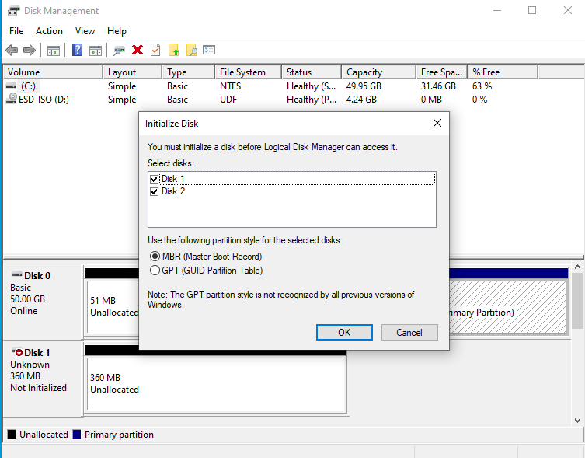

Что бы была возможность создать не только Simple Volume, то конвертируем диск в динамический

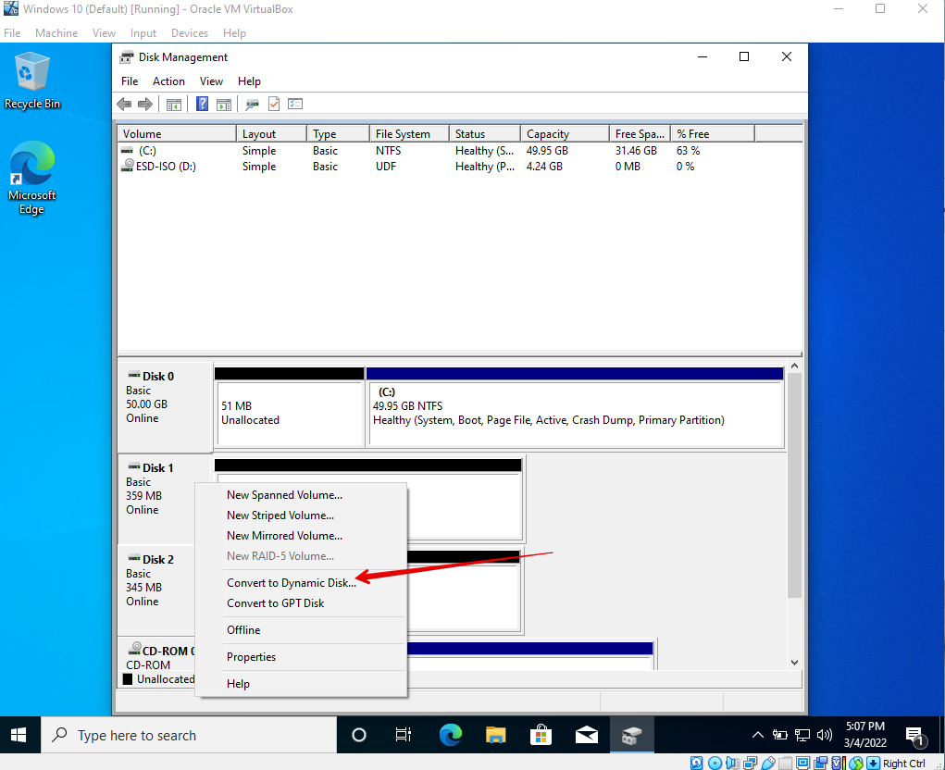

Создаем Mirrored Volume, используя 2 динамических диска.

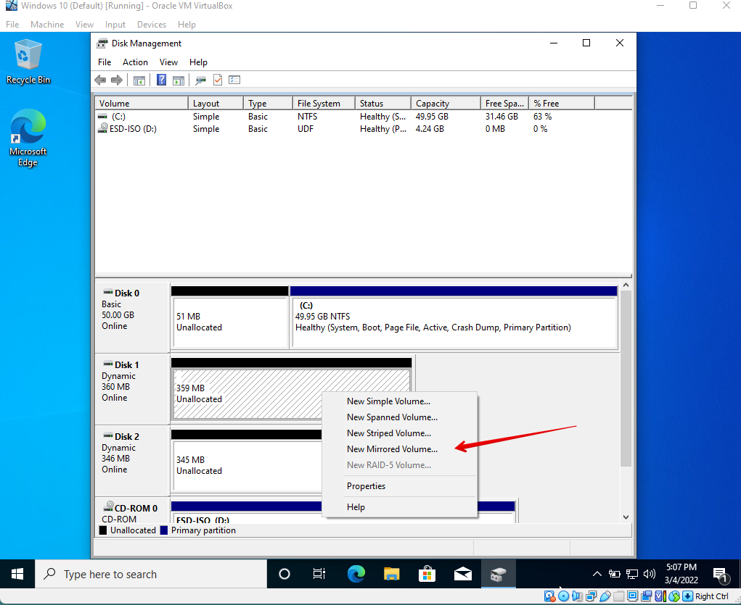

**Убираем место с диска**

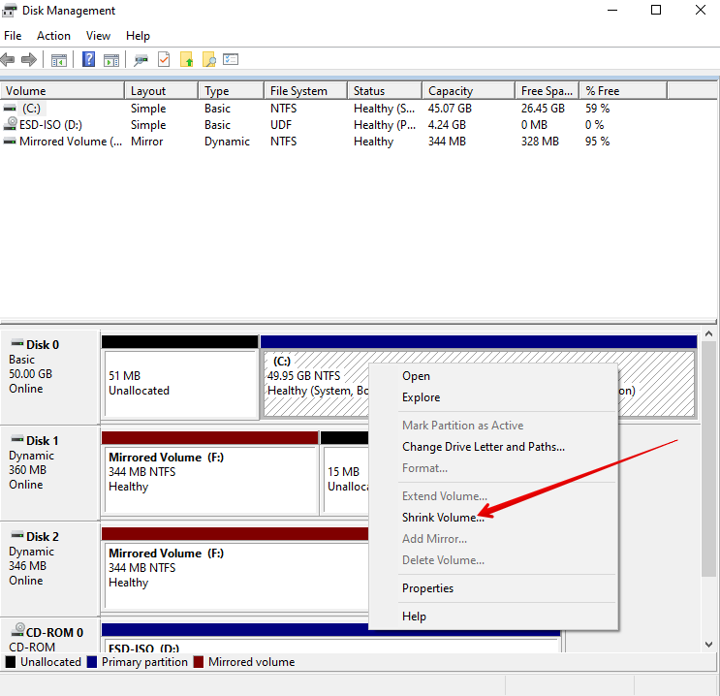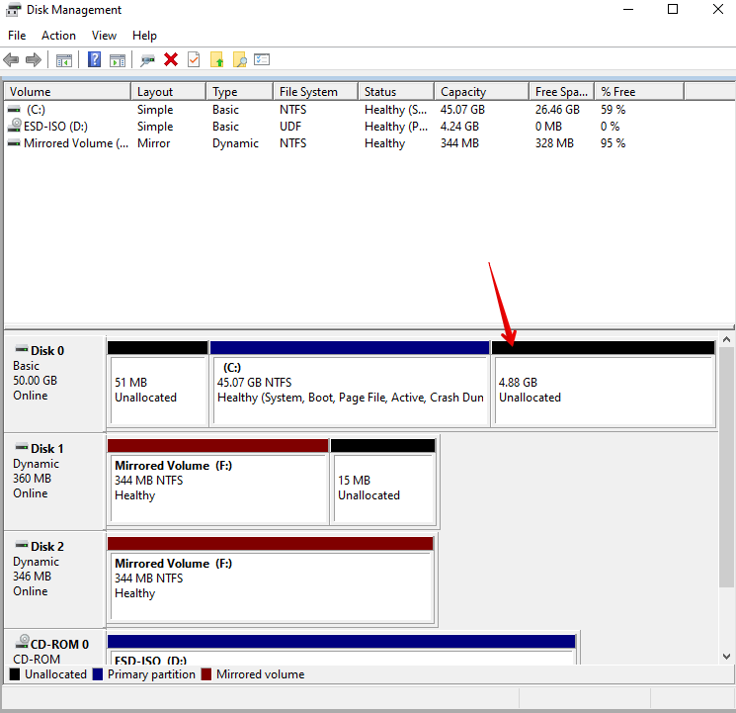

**Расширяем диск**

